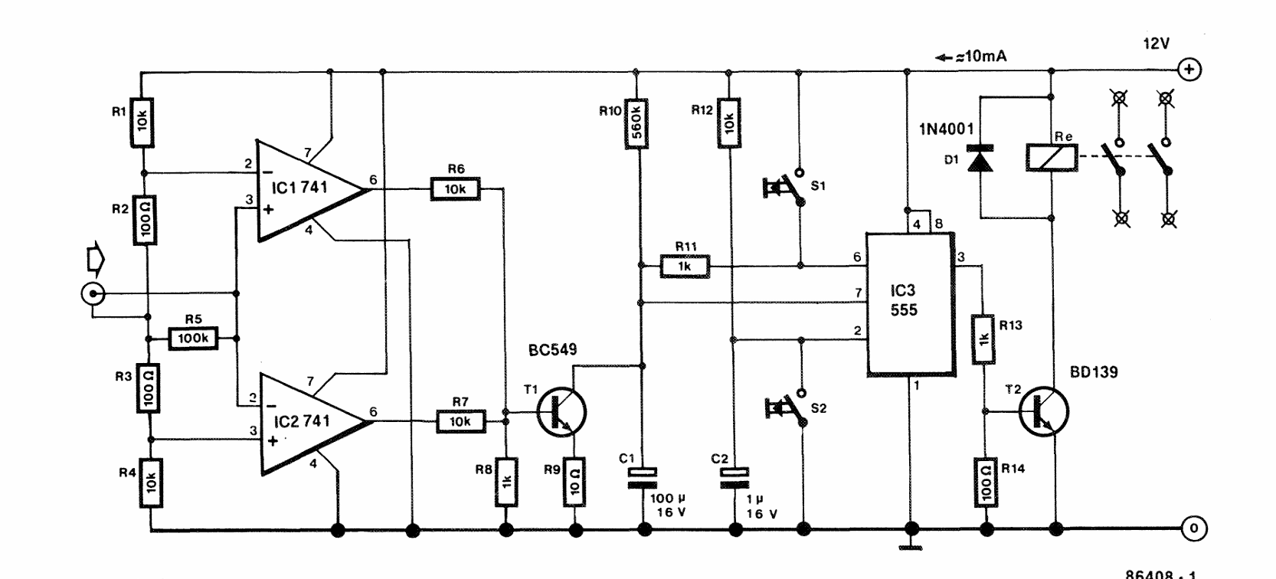

# 🔊 Audio-Controlled Mains Switch – Working Principle

## I. **Core Purpose**

* **Automatic control of a mains-powered device** based on audio presence.
* **Behavior**:
  + **Audio present → Device ON**
  + **Audio stops → Device OFF (after ~2 minutes delay)**
  + **Manual override → User can force ON/OFF anytime**

## II. **Step-by-Step Operation**

### 1. **The “Ears” – Audio Detection**

* **Biasing**: Audio AC signal is shifted to **+6V DC** so op-amps (IC1, IC2) can handle it.
* **Window comparators**: IC1 & IC2 set a small voltage window around +6V.
* **Detection**: If audio goes outside the window → comparator outputs a **HIGH pulse**.
* **Result**: Generates “**Sound Detected**” pulses for each strong audio peak.

### 2. **The “Brain” – Retriggerable Timer (IC3: 555 Timer)**

* **Sound present**:
  + “Sound Detected” pulse keeps transistor **T1 ON** → capacitor **C1 held at 0V**.
  + 555 output forced **HIGH → countdown never starts**.
* **Sound stops**:
  + T1 turns **OFF**, capacitor **C1 charges slowly via R10**.
  + After ~2 min, C1 reaches threshold → 555 output flips **LOW**.
* **Meaning**: 555 timer acts as a **delay OFF controller**.

### 3. **The “Muscle” – Relay Switching**

* **Output HIGH (appliance ON)**:
  + Driver transistor **T2 ON** → relay energized → appliance powered.
* **Output LOW (appliance OFF)**:
  + T2 OFF → relay de-energized → appliance disconnected.

### 4. **The “User Interface” – Manual Control**

* **S2 (Manual ON)**: Forces 555 output HIGH → appliance ON.
* **S1 (Manual OFF)**: Forces 555 output LOW → appliance OFF immediately.